

*Feels uncomfortable*

*Hard to follow the diet*

Feels healthy

Enrich the lives of elderly people with the modern ways

*Difficult to find food interest*

*Measures of Success*

*Starts a food diary*

*I couldn't find the food that I want*

*Looking for food that matches interest*

Will try to maintain the diet properly

Menu with healthy receipes

*Do you following the diet properly?*

*Share your feedback*

*Maintaining the calories level*

*Does it working?*

*People looking for alternatives and more practical ways of overcoming their disability*

Empathy Map Canvas

Gain insight and understanding on solving customer problems.

1

Build empathy and keep your focus on the user by putting yourself in their shoes.

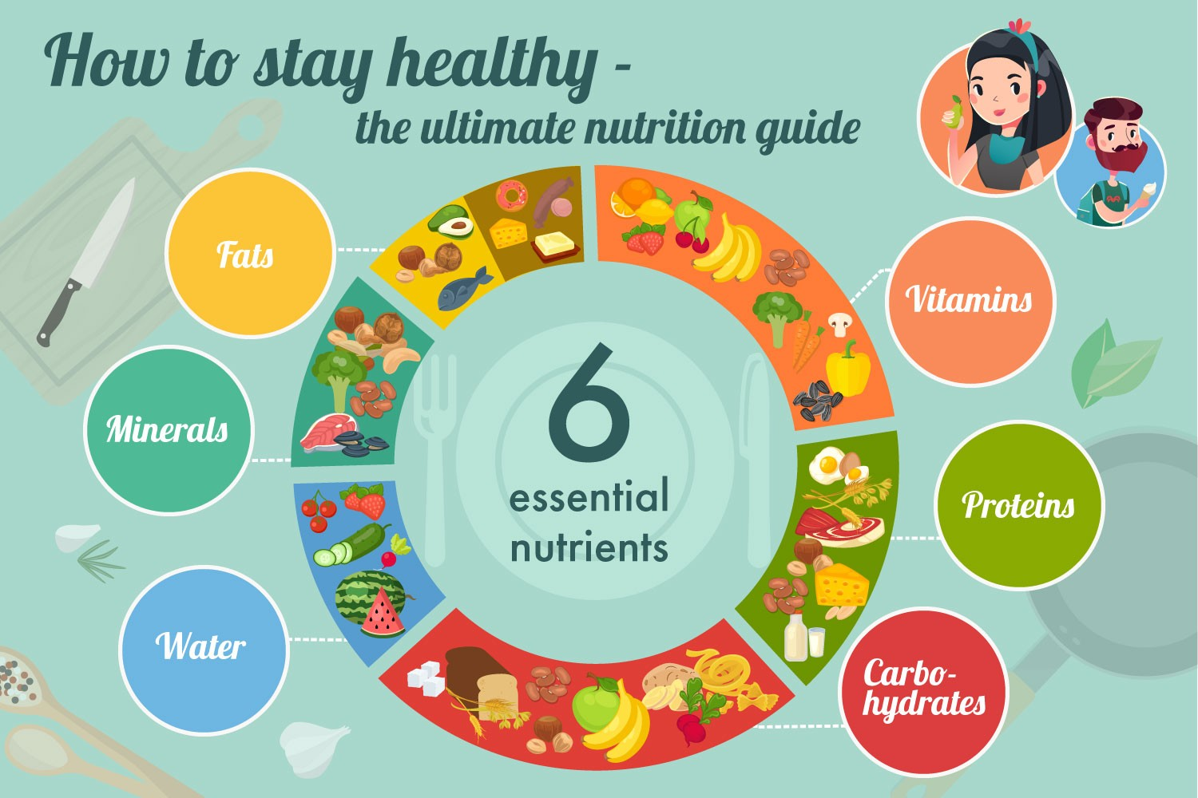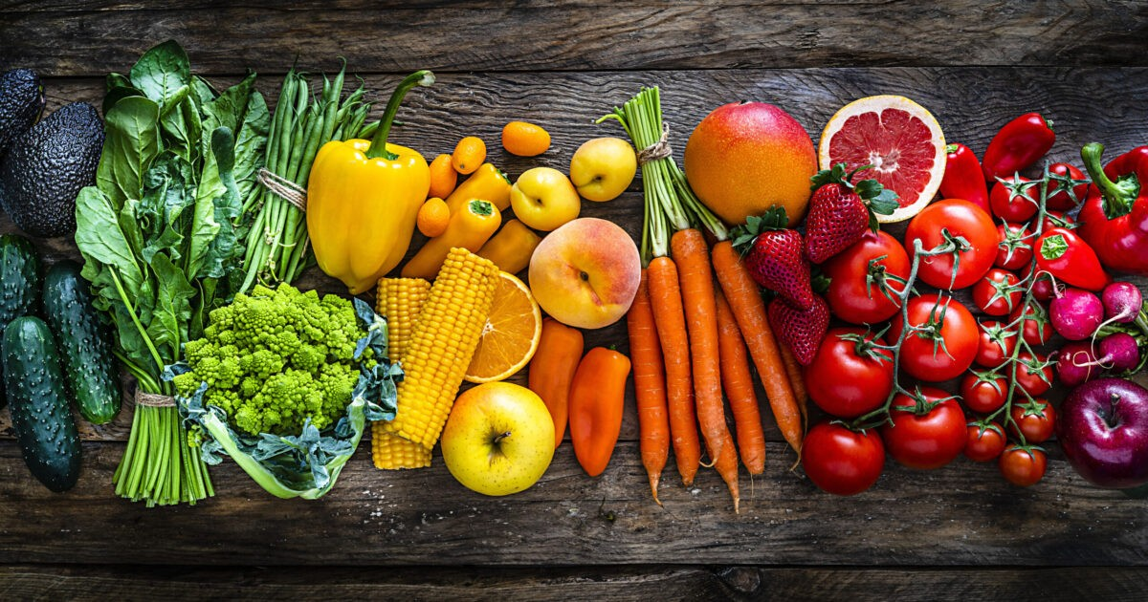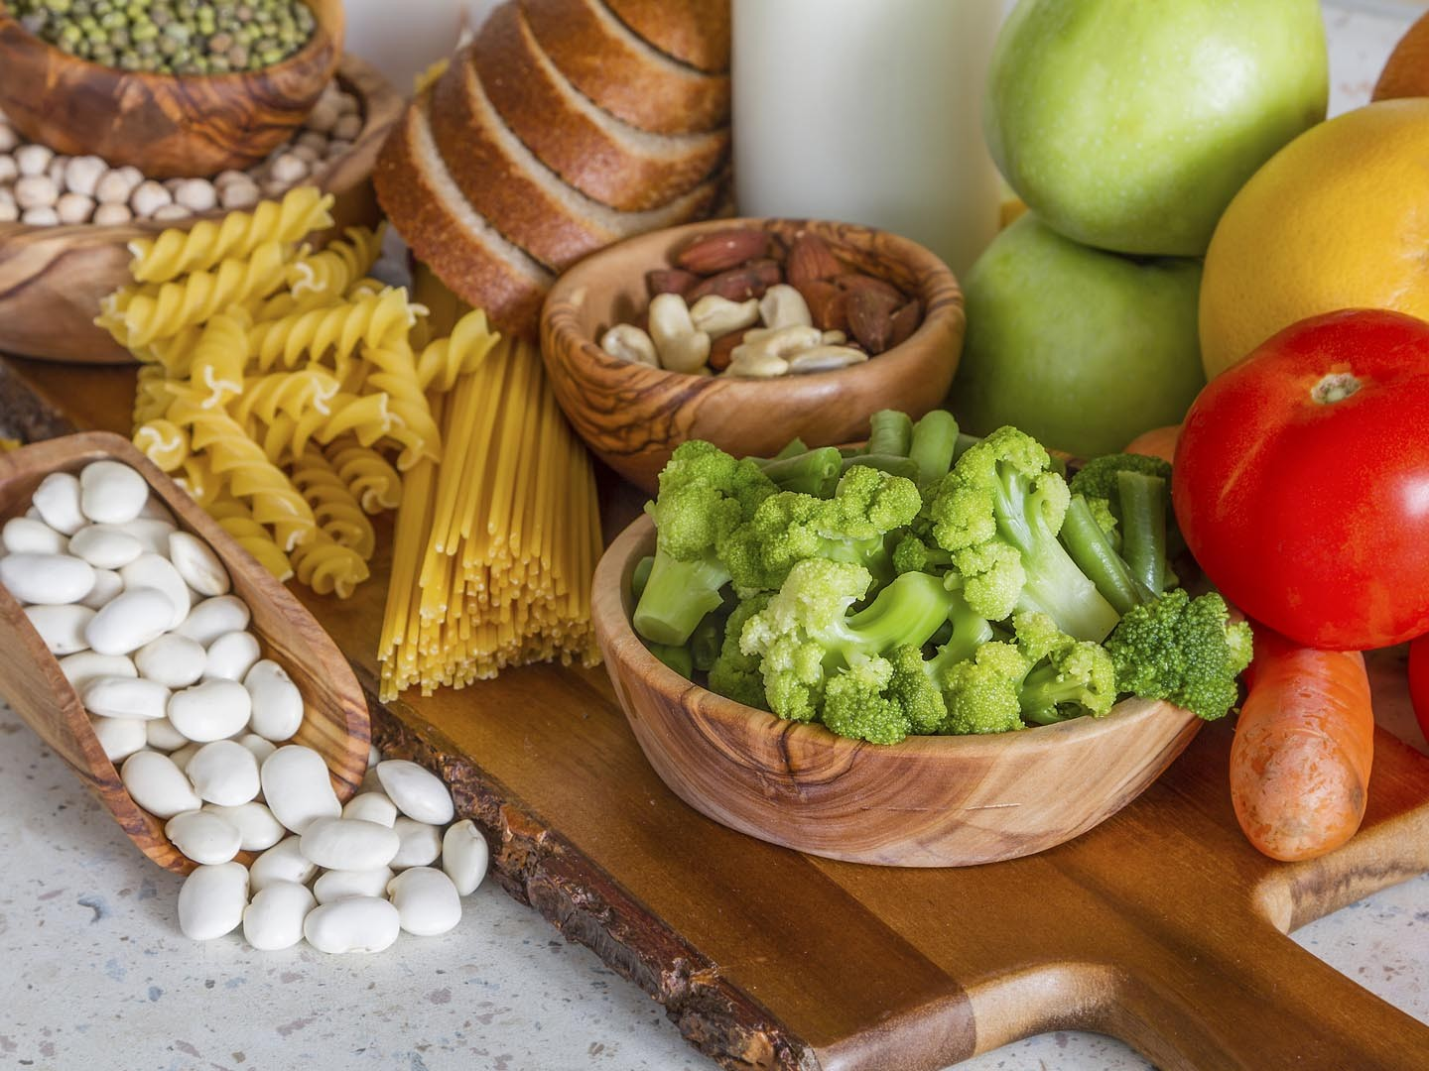

*what should I eat today?*

*Does'nt want junk food*

*Feeling healthy*

I need to plan my diet properly